# Modelling for a client

Contents

Modelling for a client 1

Introduction 1

Planning 1

The questionnaire 1

Results from the questionnaire 2

Evaluation 2

Mood board from client’s answers 3

## Introduction

The task has been set to 3d model a client’s bedroom biased on a questionnaire designed to get all the relevant information to recreate the room. The model doesn’t have to be exact, but the more detail received from the client the higher chance that the model will resemble the clients room.

## Planning

When planning a questionnaire, it is important to be specific with the questions so that the responses will be useful rather than having an open-ended answer and receiving an open answer. For this I will be using google Docs to provide the questionnaire to the client as this can be sent online but by doing so I will need to extract the right information from the client.

The bedroom itself will need research because there are infinite ways their rooms can be designed meaning it would be ideal to produce sketches from the client’s information to aid in the 3D development.

To accompany the visualisation of the room, there will be ambient sounds such as cars, people talk and other background noise to provide the most accurate experience.

## The questionnaire

Within the questionnaire, I needed to collect as much relevant information about the client’s room. For this I asked about the room first with questions such as: What is the shape of your room? What colour? How many windows and where are they located.

Collecting correct from the client is vital to provide a suitable result. Thus, I am using a written questionnaire to get specific answer from basic questions then performing an interview to extract primary information straight from the client.

## Results from the questionnaire

After consulting with the client, I have received the questionnaire, and these are the responses:

1. What shape is your bedroom?
   1. Rectangular
2. What colour is your bedroom?
   1. Cream
3. How many windows does your room consist of?
   1. 1
4. Where is your window positioned?
   1. The window is located opposite the door on the back side of the room against the wall
5. Do you have any furniture in your room?
   1. I have a desk and office chair on the right wall at the back section of the room and above the desk there are 2 shelving units
6. Where is the bed located within the room?
   1. The bed is in the corner opposite the desk in the back-left portion of the room.
7. What type of flooring do you have?
   1. My room as laminate
8. Do you have any artwork located in your room?
   1. I have 2 posters situated on the back and left wall over the bed

## Evaluation

From the information collected from the client, I can make a basic assumption of how the bedroom is designed and with this I can create some initial sketches and start to create simple models. After collecting the information from the client, the amount of questions I provided don’t provide the most amount of information thus I will be conduction another questionnaire but I shall be doing so verbally to receive information straight from the client.

## Mood board from client’s answers

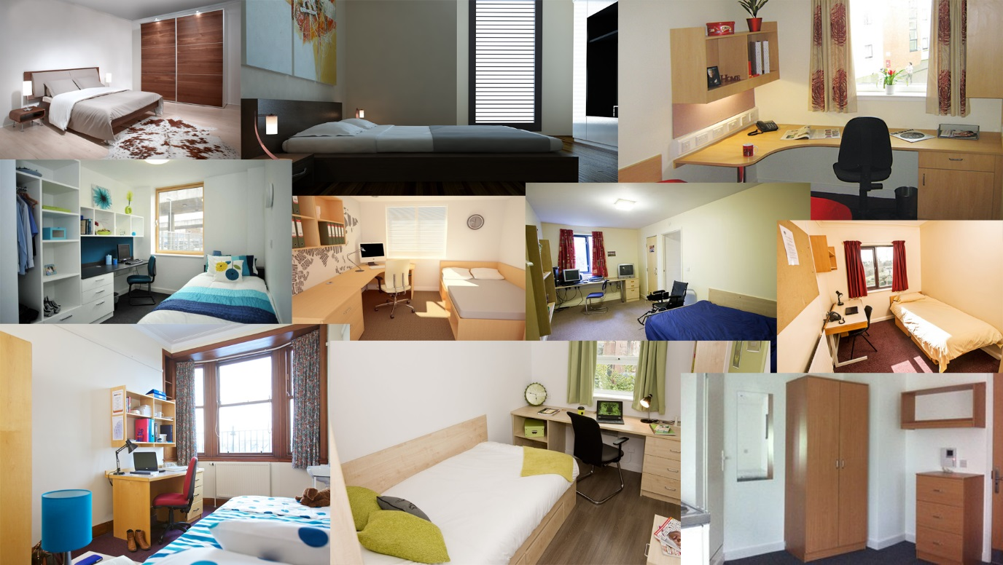

The images within the mood board show that in the types of rooms my client has described are all simple and contain a form of desk with accompanying chair. With these images I can start to create the models for the client’s room.

Image References

<http://www.zanita.info/wp-content/uploads/2012/02/simple-bedroom-design-ideas-classic.jpg>

<http://www.sellmyoil.com/wp-content/uploads/2017/08/cool-Simple-Bedroom-Design-And-Furniture-For-Simple-Bedrooms.jpg>

<https://beyondstorage.co.uk/wp-content/uploads/2015/05/student-bedroom.jpg>

<https://www.genesys-uk.com/images/products/student-bedroom-furniture3399.jpg>

<http://www.crm-students.com/fileadmin/content/schemes/Dundee/The_Hub/Gallery_images/Dundee-Student-Accommodation-The-Hub---bedroom_v2.jpg>

<https://www.liverpool.ac.uk/accommodation/halls/on-campus-accommodation/liberty-prospect-point/pp-student-bedroom3.jpg>

<https://www1.bournemouth.ac.uk/sites/default/files/styles/lightbox/public/assets/images/Student-village-bedroom2.jpg?itok=djoAiImI>

<https://www.st-andrews.ac.uk/media/residential-and-business-services/studentaccommodationservices/residences/mcintoshhall/12%20-%20McI.jpg>

<https://www.iqstudentaccommodation.com/sites/default/files/Salford-Site-Header3.jpg>